Lab#15 b part

Task#9:

#include<iostream>

#include<fstream>

#include<string>

using namespace std;

int main()

{

string str;

float gpa;

string name;

cout << "Enter name: ";

cin >> name;

cout << "Enter GPA: ";

cin >> gpa;

cout << "Enter Roll Number: ";

cin >> str;

ifstream in;

ofstream out;

out.open("Firstfile.txt");

out << name << endl;

out << str <<endl;

out << gpa;

out.close();

char ch;

in.open("Firstfile.txt");

while(!(in.eof()))

{

in.get(ch);

out<<ch;

}

System(“pause”);

}

Output:

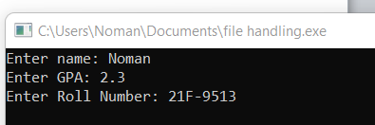

File output:

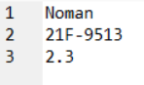

Task #10:

#include<iostream>

#include<fstream>

using namespace std;

int main()

{

/\*string str;

float gpa;

string name;\*/

ifstream in;

ofstream out;

in.open("C:\\Users\\Noman\\Documents\\Firstfile.txt");

char ch;

while (!(in.eof()))

{

in.get(ch);

out << ch;

cout << ch;

}

in.close();

system("pause");

}

Output:

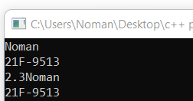

Task #11:

#include<iostream>

#include<fstream>

using namespace std;

int main()

{

int num1, num2,sum;

cout << "Enter the two Numbers ";

cin >> num1 >> num2;

sum = num1 + num2;

ofstream out;

ifstream in;

out.open("newfile.txt");

out << sum;

out.close();

in.open("newfile.txt");

char ch;

while (!(in.eof()))

{

in.get(ch);

}

cout << sum << endl;

system("pause");

}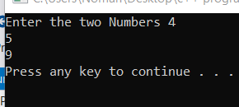

File output:

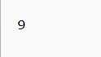

Task #12:

#include<iostream>

#include<fstream>

using namespace std;

int main()

{

int num1, num2, sum, sub, mul, divi;

cout << "Enter the two Number :";

cin >> num1 >> num2;

sum = num1 + num2;

sub = num1 - num2;

divi = num1 / num2;

mul = num1\*num2;

ofstream out;

ifstream in;

out.open("File1.txt");

out << sum << endl;

out << sub << endl;

out << divi << endl;

out << mul << endl;

out.close();

char ch;

in.open("File1.txt");

while (!(in.eof()))

{

in.get(ch);

}

cout << "The sum is : " << sum << endl;

cout << "The subtraction is :" << sub << endl;

cout << "The division is" << divi << endl;

cout << "The Multiplication is " << mul << endl;

system("pause");

}

Output:

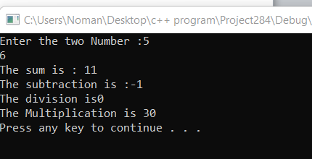

File output:

